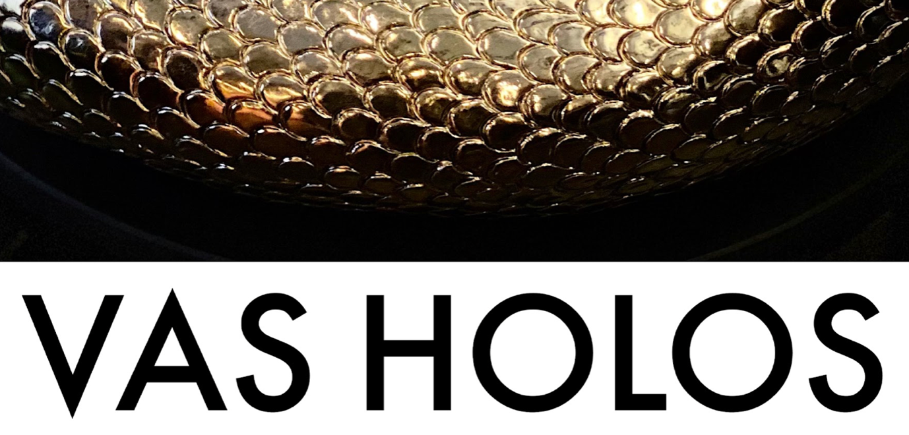

**Claire Bridge • Jia Jia Chen • Nina Sanadze • Katie Stackhouse**

**Exhibition Media Release**

**Opening Reception Thurs May 5th, 6- 8 pm**

**Exhibition open May 6 - 15, 2022, 11 am - 6 pm daily**

**Meat Market’s Stables, 2 Wreckyn Street, North Melbourne**

At the unprecedented time of political, ecological, cultural and existential rupture and void,   
*Vas Holos* exhibition connects us with all these concerns while offering the viewer a tender, compassionate, caring and nurturing vessel to contain our thoughts and feeling, allowing us to feel the grandeur of nature, beauty of humanity, rapture and hope.

**Claire Bridge, Jia Jia Chen, Nina Sanadze** and **Katie Stackhouse**, explore concepts of wholeness (holos) and the vessel (vas) through rupture and embodiment, translated across sculpture, video and installation. Whether the vessel be of a human/more-than-human body, the earth, body politic or of culture, each contemplates our complex mesh of interrelations as containers of emergent, transformative change.

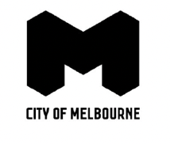

This project is supported by the City of Melbourne arts grants.

Banner image: Claire Bridge, 2021, *From which all emerges and returns*, glazed stoneware ceramic, 50 x 50 x 11.5 cm.

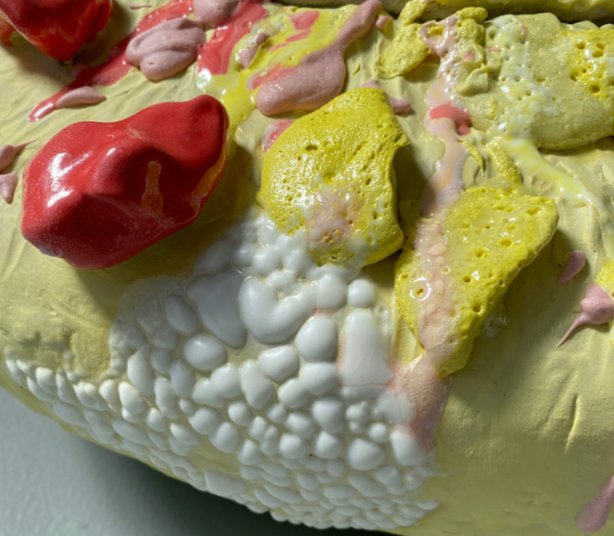**CLAIRE BRIDGE**

Fusing the mythic and grotesque, Claire Bridge presents visceral sculptural ceramics embodying celebratory colour and exuberant excess. Drawing on a synthesis of her Indian Assamese and Anglo-European heritages, she undertakes practices of rupture, re-patterning and repair in blistered sculptural forms akin to the body, cells or ouroboros. For Bridge, myth is as a vessel trans-versing porous time, alive with potential to transmit and transform culture. Holding the vessel as a central idea and image, her work addresses ‘voice’ and ‘agency’ in its varied dimensions, spoken and unspoken. Bridge’s work invokes *repair* in the dual aspects of its meaning, as both ‘to mend’ and to ‘come home’. Embedded within her processes, objects, and materials, are gestures of repair of personal and collective wounds, opening ruptures of transformational potential and plasticity.

Informed by tales of Medusa, Bridge re-signifies and empowers the monstrous/ fierce feminine that has been subjugated or relegated to “witch” and “bitch”. (Recall the rhetoric that surrounded Australia’s first woman Prime Minister or the belittling response to Grace Tame’s ‘side-eye’ glance.)

[clairebridgeartist.com](http://clairebridgeartist.com/) Instagram @clairebridge  
Image: Claire Bridge, *Soma-Witness*, 2021, glazed stoneware ceramic, wax, pearls, 51 x 49 x 22 cm.

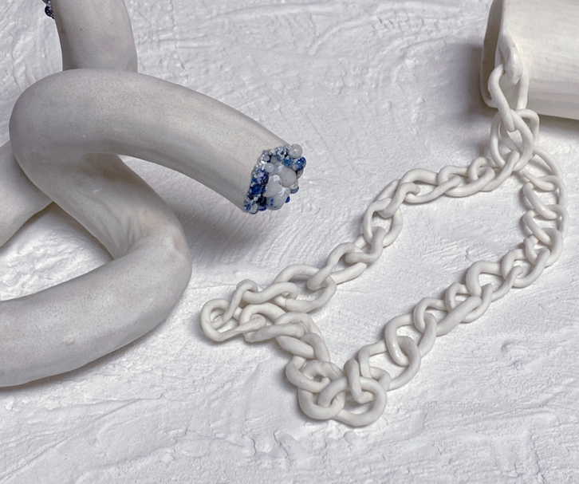**JIA JIA CHEN**

'Old, New, Borrowed and Blue' is a homage to water and fountains. Composed through a dialogue of ceramic fragments that romantically re-imagines the Venetian cistern in marriage with ‘Blue & White’ porcelain.  And constructed as a set-piece of reflexive contemplation, informed by the classical courtyards of Roman and Chinese civilizations that shaped and reflected philosophical and organisational principles. This work is driven by subconscious desires for placemaking and operates as a metaphorical vehicle for allegorical exchange between Marco Polo’s travelogue that introduced China to the West, and Italo Calvino’s poetic literary inversion in ‘Invisible Cities’.   A journey into an era before the transmission of fast images. When communication was slower, and the cross-fertilisation of culture and migration of aesthetic forms was individually absorbed and conveyed.

My practice examines the complex history of economic and cultural transfer with the legacies of Chinese porcelain. Exploring how objects transform into holding places, locating devices and vehicles for narrative and pleasure.

[jiajiajichen.com](http://jiajiajichen.com/) Instagram @jiajiajichen

Image: Jia Jia Chen, *Old, New, Borrowed and Blue*, 2022, Porcelain, Blue and White Glaze beads, render, polystyrene, pvc, water, pump, dimensions variable.

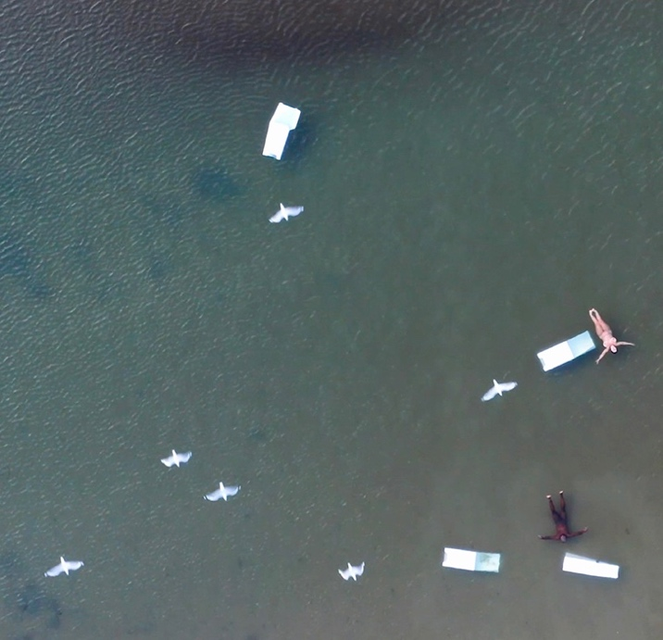**NINA SANADZE**

Nina Sanadze’s new monumental video and sculptural installation *Re-election Day [Water]* is epochal. Bringing the feeling of surrender into the realm of visual poetry and splendour, we are invited to contemplate our own fragility and the finality of civilisation. Broadly conceived against the background of environmental, political and demographic crises in the world in the 21st century, it is deliberately presented on the verge of the upcoming Federal election in Australia. The humble cardboard election booth becomes a sculptural form and a symbol of hope, choice and change. The first work in this series titled *Re-election Day [Fire]* was exhibited in the aftermath of New Year fires in March 2020.

[ninasanadze.com](http://ninasanadze.com/) Instagram @nina_sanadze

Image: Nina Sanadze, *Re-election Day [Water],* 2022*,* video still.

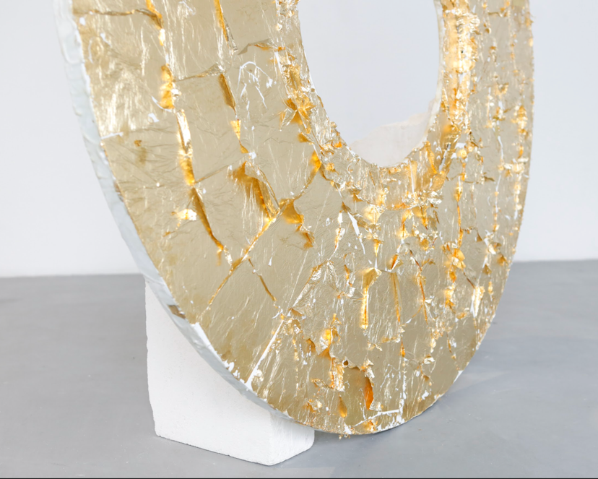

**KATIE STACKHOUSE**

I am driven to make work using the materials of bronze and beeswax due to the transformative properties and elemental vitality that these materials hold. Some of these sculptures are made to be physically activated by either an action or performance and I work towards creating a relational dynamic that reflects the ways that ecologies move in and out of synchronicity and balance due to forces that are human and non-human. Functioning like bodies, the sculptural vessel is a container to conjure, protect, nurture and grow whilst the portal forms function as thresholds. My research investigates the way that sound, and body performance can interact with sculptural objects to activate the tensions between the materiality and ephemerality within a work. Throughout my practice, I consider materialist philosophies and the intersections between pedagogies of ecological stewardship, politics of care, feminism(s) and theories of place. The politics in my artworks are poetic in form and express concerns of care for place, communities, and ecologies. The sculptures became imbued and activated through methods of production, voice and performance.

[katiestackhouse.com](http://katiestackhouse.com/) Instagram @katie__stackhouse  
Image: Katie Stackhouse, *Disc for Change*, plaster, beeswax, acrylic paint, wood, gold leaf, 150 x 150 x 60cm.

Katie Stackhouse:   
“*The sculptural forms of the vessels function simultaneously* *as protective and containing – holding what is precious to the human interior life*.”

Jia Jia Chen:   
*“Chinese Blue and White porcelain was the original global luxury product; desired, imitated and perpetually adapted into every culture to which it arrived. My reinterpretation of ‘White Gold’ continues this passage of assimilation and adaptation as a medium for nostalgic merger of East, West inheritances in harmonious union.”*

Nina Sanadze: *“Elevating mundane objects like cardboard election booths into potent sculptural forms and then grafting them into contradictory settings, helps me to evoke powerful unconscious associations and to initiate storytelling. As stark white drowning vessels, the frail cardboard election booths are offset by the dark and dense vessel of the ocean water. This ocean holds floating human bodies which are depicted in the liminal state between rest and tension or, perhaps, life and death. The mesmerising beauty and the spiritual quality of water also holds the ever-present flipside – latent danger and the grotesque power of destruction.”*

Claire Bridge:   
*“Western culture has a tendency to deny structural violence and erase scars. My work resists this denial by acting as witness to the wounded psyche and body through visible ruptures and tactile fragmentations.”*

Katie Stackhouse:   
*“A vessel is a container to conjure, protect, nurture and grow. It is both empty and full. It has the capacity to contain thoughts, songs, desires and love. It holds potential and time; a form to contemplate the fragility of life and its interconnectedness.”*

Claire Bridge:   
*“In my practice, repair is a vital practice of cultural resistance. Against a national backdrop of climate disasters and systemic gendered violence, the term ‘resilience’ gets bandied about like a badge awarded to ‘good’ survivors. As if we are to simply “bounce back and carry on” while the causative structures remain unchanged. My work speaks to something more, of a hope towards thriving, ongoing-ness and the restorative futures of an evolving culture.”*

Rhana Devenport (ONZM), director of the Art Gallery of South Australia:

*“Nina Sanadze is compelled to respond to some of the great forces of our time – ideology, authority, monuments, conflict and survival – amidst the transient yet insistent fabric of memory, beauty and tenderness. Evocative and dramatic, Nina eschews the once victorious into a tumbling morphic vortex of fragility. Nina possesses a powerful ability to draw on the political, the familial and the poetic with great clarity and aesthetic poignancy.”*

***Vas Holos – Essay by Josephine Mead***

“*To rupture; to remain whole; to pour; to fill; to rebuild; to retain.* One of my initial artistic encounters with the vessel was within the *studio*. The *studio*; *the primary vessel for making.*” [Read more…](https://app.box.com/s/ipbe4vdybx5rygeidutk1ooy5cj6y8pe)

download the PDF: <https://app.box.com/s/ipbe4vdybx5rygeidutk1ooy5cj6y8pe>

**Media comment:**

**Claire Bridge:** +61 417313623; [bridge.claire@gmail.com](mailto:bridge.claire@gmail.com)

<clairebridgeartist.com>**;** <https://www.instagram.com/clairebridge/>

**Katie Stackhouse:** +61 499220301; [katie.stackhouse.mail@gmail.com](mailto:katie.stackhouse.mail@gmail.com)

[katiestackhouse.com](http://katiestackhouse.com/)**;** <https://www.instagram.com/katie__stackhouse/>

**Jia Jia Chen:** +61 401526788**;** [jiajiachenhere@gmail.com](mailto:jiajiachenhere@gmail.com)

<jiajiajichen.com>**;** <https://www.instagram.com/jiajiajichen/>

**Nina Sanadze:** +61 432 688 416; [nina@ninasanadze.com](mailto:nina@ninasanadze.com);

<https://ninasanadze.com>**;** <https://www.instagram.com/nina_sanadze/>